# Assignment 3.1

1. Select a simple task: "Write a Python function to check if a  
   number is prime."  
   2. Use different prompting strategies to generate the solution:  
   a) Zero-Shot – no examples.  
   b) One-Shot – one example provided.  
   c) Few-Shot – multiple examples provided.  
   d) Context-Managed – detailed prompt with constraints  
   and instructions

Sample Prompts  
● Zero-Shot:  
Write a Python function to check if a number is prime

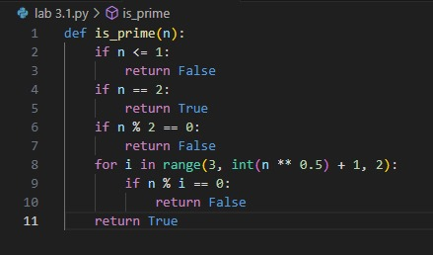

● One-Shot:  
Example: Input: 5 → Output: Prime. Now, write a function  
to check if a number is prime.

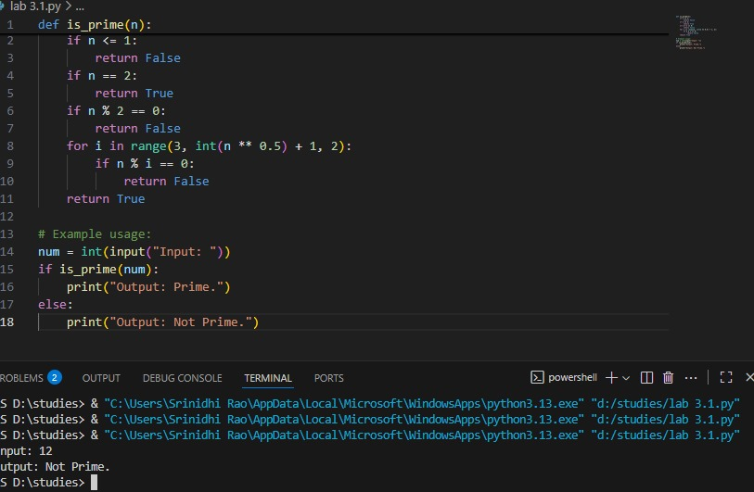

● Few-Shot:  
 Example 1: Input: 7 → Output: Prime

Example 2: Input: 10 → Output: Not Prime  
 Example 3: Input: 2 → Output: Prime  
 Generate the function accordingly

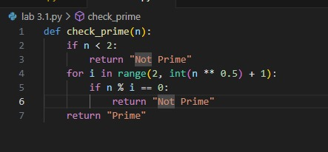

Task: Mobile Data Usage Billing Application (1.0 Marks)  
Objective:  
Use Python programming and AI-assisted coding tools to create an  
application that simulates mobile data billing for a telecom service  
provider.  
Instructions  
1. Use GitHub Copilot or Google Gemini to assist in writing the  
program.  
2. Read the following inputs from the user:  
o Data Consumed (in GB)  
o Plan Type (Prepaid / Postpaid)  
o Additional Services Used (e.g., caller tune, OTT  
subscription, etc.)  
3. Implement billing logic to calculate:  
o DC (Data Charges) – charges based on data  
consumption  
o VC (Value-added Charges) – charges for additional  
services  
o Tax – applicable tax on the total bill  
4. Display an itemized bill showing:  
o Plan Type  
o Data Usage and Charges  
o Value-added Services and Charges  
o Tax  
o Total Bill Amount  
Requirements  
● Students must refer to their actual mobile bill for charge  
structure (data cost, service fees, taxes) to make the program  
Week2 -  
Monday

realistic.  
● AI assistance (Copilot/Gemini) must be used to generate and  
refine the initial code.  
Deliverables  
● AI prompts used for code generation.  
● AI-generated Python code and any optimized version.  
● Screenshots of:  
o AI interactions  
o Program execution and output  
o Comparison with the student’s actual mobile bil

prompt:

Create a Python program for a Mobile Data Usage Billing Application for a telecom service provider. The program should:

* Ask the user to input:
  + Data Consumed (in GB),
  + Plan Type (Prepaid or Postpaid),
  + Additional Services Used (like caller tune, OTT subscriptions, etc.)
* Apply realistic charge structures (can be assumed based on a real mobile bill):
  + Data Charges (e.g., ₹10 per GB for Prepaid, ₹8 per GB for Postpaid)
  + Value-added Services Charges (e.g., caller tune ₹30/month, OTT ₹149/month, etc.)
  + Apply 18% tax on total (data charges + value-added services)
* Perform the following calculations:
  + DC (Data Charges) based on plan and usage,
  + VC (Value-added Charges) based on selected services,
  + Tax = 18% of subtotal,
  + Total Bill = DC + VC + Tax
* Display a detailed bill including:
  + Plan Type,
  + Data Usage and Charges,
  + List of Additional Services and their Charges,
  + Tax Amount,
  + Total Bill Amount."

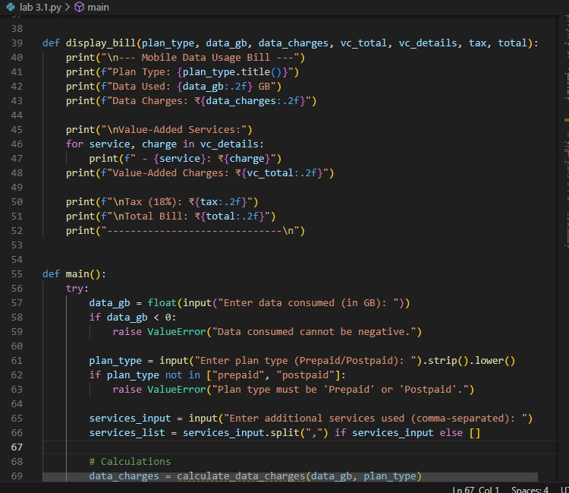

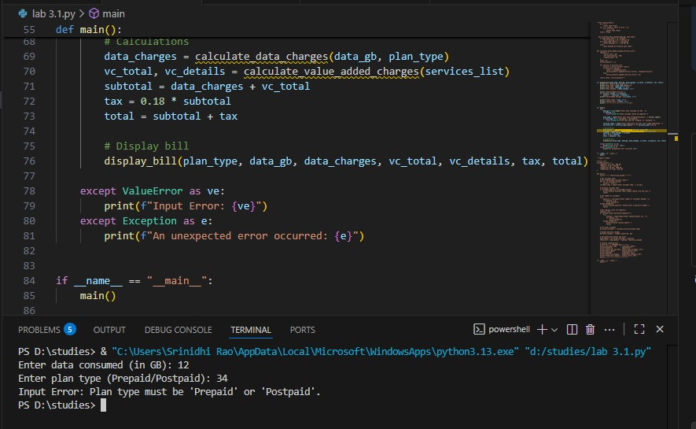

Task: Develop an LPG Billing System (1.0 Marks)  
Objective  
Apply your Python programming skills and utilize AI-assisted  
coding tools to build an application that calculates the LPG bill  
based on specified customer inputs and billing parameters.  
Instructions  
1. Use GitHub Copilot or Google Gemini to assist in writing  
and refining the program.  
2. Read the following user inputs:  
o Cylinder Type (Domestic 14.2 kg / Domestic 5 kg /  
Commercial 19 kg / Commercial 47.5 kg)  
o Number of Cylinders Booked  
o Subsidy Amount (applicable only for domestic  
cylinders)  
3. Refer to the given LPG Price List to determine the price per  
cylinder:  
o Domestic LPG (14.2 kg) → ₹905.00  
o Domestic LPG (5 kg) → ₹335.50  
o Commercial LPG (19 kg) → ₹1,886.50  
o Commercial LPG (47.5 kg) → ₹4,712.00  
Week2 -  
Monday

o Delivery Charges (₹10 to ₹50)  
4. Implement the billing formula:  
Bill Amount = (Price per Cylinder × Quantity) - Subsidy (if applicable) + Delivery Charges  
5. Calculate and display an itemized bill including:  
● Cylinder Type  
● Number of Cylinders  
● Base Amount  
● Subsidy  
● Delivery Charges  
● Total Bill Amount  
Deliverables  
● A report containing:  
o AI prompts used to generate the program  
o AI-generated Python code

prompt:

Write a Python program for an LPG Billing System. The program should:

* Take user input for Cylinder Type (Domestic 14.2 kg / Domestic 5 kg / Commercial 19 kg / Commercial 47.5 kg),
* Ask for the Number of Cylinders Booked,
* Ask for Subsidy Amount (applicable only for domestic cylinders),
* Ask for Delivery Charges (between ₹10 and ₹50),
* Use the following fixed price list:
  + Domestic 14.2 kg → ₹905.00
  + Domestic 5 kg → ₹335.50
  + Commercial 19 kg → ₹1,886.50
  + Commercial 47.5 kg → ₹4,712.00
* Calculate the bill using the formula:  
  **Bill Amount = (Price per Cylinder × Quantity) - Subsidy (if applicable) + Delivery Charges**
* Display an itemized bill with:
  + Cylinder Type
  + Number of Cylinders
  + Base Amount
  + Subsidy
  + Delivery Charges
  + Total Bill Amount."



